What is Feature Engineering

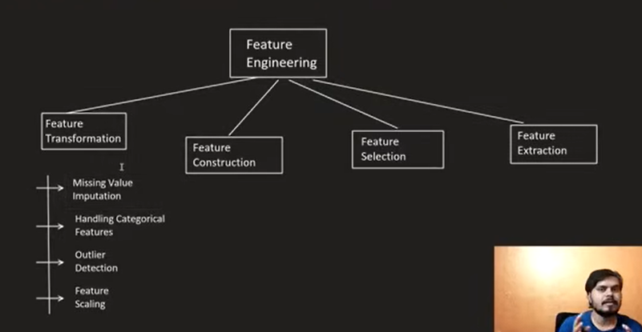

What is Feature Engineering?
Definition:
Feature Engineering is the process of transforming raw data into a format that helps machine learning algorithms perform better.
According to Wikipedia:
"Feature engineering is the process of using domain knowledge to extract features from raw data that improve the performance of machine learning algorithms."

Key Idea
- Raw data cannot always be directly fed into ML algorithms.
- Data must be cleaned, transformed, and prepared.
- Good feature engineering often improves model performance more than choosing a more complex algorithm.

Why is Feature Engineering Important?
- Improves model accuracy.
- Makes learning easier for algorithms.
- Reduces noise in data.
- Handles missing or inconsistent values.
- Reduces training time.
- Helps prevent overfitting.
A simple algorithm with well-engineered features can outperform a powerful algorithm with poor features.

Position in Machine Learning Pipeline
- Data Collection
- Exploratory Data Analysis (EDA)
- Feature Engineering
- Model Training
- Evaluation
- Deployment

Main Types of Feature Engineering
There are 4 major categories:

1. Feature Transformation
Transform existing features into a better form.

Common Techniques

a) Missing Value Imputation
Missing values are common in real-world datasets.
Methods:
- Delete rows/columns
- Mean imputation
- Median imputation
- Mode imputation
- Advanced imputation techniques

b) Handling Categorical Variables
Machine learning algorithms usually require numerical inputs.
Convert categories into numbers using techniques like:
- One-Hot Encoding
- Label Encoding
- Ordinal Encoding
Example:
Animal | Dog | Cat | Cow
Dog | 1 | 0 | 0
Cat | 0 | 1 | 0
Cow | 0 | 0 | 1

c) Binning
Convert numerical values into categories.
Example:
Age → Category
- 0–12 → Child
- 13–19 → Teenager
- 20–40 → Adult
- 40+ → Senior

d) Outlier Detection
Outliers are unusual observations that differ greatly from the rest.
Example:
- Most students score around 50.
- One student scores 990.
Outliers can distort many ML algorithms.
Common techniques:
- IQR Method
- Z-score
- Isolation Forest

e) Feature Scaling
Different features may have different scales.
Example:
Age = 25
Salary = 80,000
Algorithms based on distance (e.g., KNN) are affected by different scales.
Methods:
- Normalization (Min-Max Scaling)
- Standardization (Z-score Scaling)

2. Feature Construction
Create new features from existing ones.
Requires:
- Domain knowledge
- Experience
- Creativity

Example (Titanic Dataset)
Existing Features:
- SibSp
- Parch
New Feature:
Family Size = SibSp + Parch + 1
Another feature:
Family Type:
- Alone
- Small Family
- Large Family
Feature construction often improves prediction accuracy.

3. Feature Selection
Select only the most useful features.
Purpose:
- Reduce dimensionality
- Reduce computation
- Improve model performance
- Remove irrelevant features

Example (MNIST)
Each image has:
28 × 28 = 784 pixels
Not every pixel contributes equally.
Feature selection removes unnecessary pixels.
Common Methods:
- Filter Methods
- Wrapper Methods
- Embedded Methods
- Forward Selection
- Backward Elimination

4. Feature Extraction
Generate completely new features from existing ones.
Unlike feature construction, feature extraction mathematically creates new representations.
Example:
Instead of using:
- Number of rooms
- Number of bathrooms
Use:
- Total Area
Another example:
Principal Component Analysis (PCA)
PCA creates new features called Principal Components that retain most of the information while reducing dimensionality.
Common Feature Extraction Techniques:
- PCA (Principal Component Analysis)
- LDA (Linear Discriminant Analysis)

Difference Between Feature Selection and Feature Extraction
Feature Selection | Feature Extraction
Chooses existing features | Creates new features
Original features remain | Original features are transformed
Easier to interpret | Harder to interpret
Removes irrelevant columns | Reduces dimensions mathematically

Important Takeaways
- Feature Engineering is one of the most important stages in Machine Learning.
- It often has a greater impact than choosing a different ML algorithm.
- The four main components are:
  - Feature Transformation
  - Feature Construction
  - Feature Selection
  - Feature Extraction
- Common preprocessing tasks include:
  - Missing value handling
  - Categorical encoding
  - Outlier detection
  - Feature scaling
- PCA and LDA are popular feature extraction techniques.
- Effective feature engineering improves both model accuracy and efficiency.

